Catering contract by informal tender
Kitchen and restaurant operation at the Devon and Exeter Institution
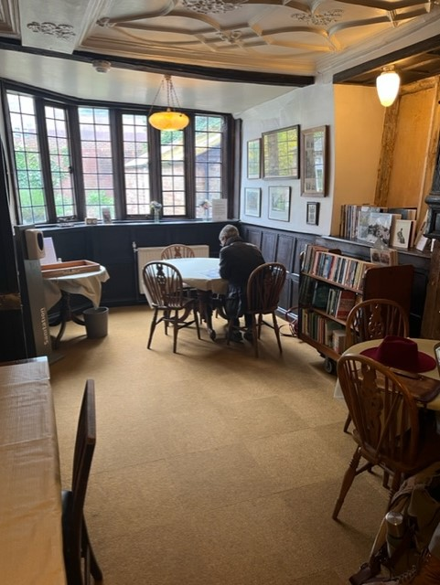
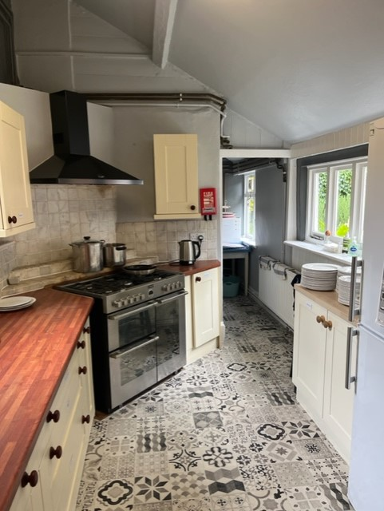

A food and beverage business opportunity
Established in 1813, the Institution’s founding aim was to promote “the general diffusion of Science, Literature and the Arts; and for illustrating the Natural and Civil History of the County of Devon, and the History of the City of Exeter”.
The DEI is open Tuesdays -Fridays 10am -5pm and Saturdays 10am -4pm with evening events throughout the year.
Since the pandemic, we have had the opportunity to review the operation and are now seeking an external partner to provide catering on site, using our facilities. Our aim is to ensure a catering offer remains available to the members, but we are open to what this looks like and how a new catering contractor could develop this to be financially successful for themselves.
The 12 cover “restaurant” was previously run by a live-in housekeeper offering traditional lunches in the Courtenay Room, which is situated at the rear of the building and accessed through the libraries. The Courtenay Room is seen by many, as the heart of the Institution and members are keen to see an offer returned.
We understand that going back to daily lunch offer, as was previously available, is not likely to be an efficient model for the contractor or ourselves, so we remain open to how the space is utilised. The ideal model for the institution will be 2-3 weekday lunches, evening event catering
(typically a buffet for 30-40 people) and catering for venue hire (typically sandwiches, salads, cakes, teas and coffees) and possibly daily cakes for purchase in the Courtenay Room.
There is limited parking on site and parking at any time will be by prior arrangement with the staff team only.
We have approximately 620 members and around 400 university members, but visitors to the Institution in any one day varies from 20-60.
Terms of business contract
Contract term: the contract will be offered up to a term of up to three years with a break clause operable by either party at any time, giving 3 months’ notice in writing, with agreed rental payable during the notice period.
The contract will not give exclusive occupation of any space within the Institution’s building. Kitchen and restaurant space will continue to be used by other staff and other users will have access to the Courtenay Room.
The contract will be a business licence, contracted out of the landlord and tenant act 1954. The term offered will be dependent on applicant’s business vision which needs to be clear in the business plan and reflected within a tender document.
Opening hours: The DEI is open Tuesdays -Fridays 10am -5pm and Saturdays 10am -4pm with evening events throughout the year.
Building repairs during the contract period: The Institution would remain solely responsible for all internal repairs and decorations including floors and ceilings fixtures and fittings.
Legislation/Standards: to comply with all health and safety, food hygiene, welfare, public health, fire precautions standards and other current relevant legislation.
Catering: to offer a high standard of food and drinks from the premises, to consider local sourcing and presentation of offer. The use of deep fat fryers is prohibited from the premises. The kitchen is well appointed and any additional catering equipment is to be provided by the contractor.
Bills: the contractor would be responsible for contributing to gas and electricity bills for the kitchen, in proportion to the scale of the catering business.
Rent: The rent is to be tendered by applicants using the attached form, clearly stating their intended business model. Rent is to be paid monthly in advance on the 1st day of each month by Direct Debit, unless otherwise agreed.
- Applicants should submit a tender for the annual rent to: Devon and Exeter Institution, 7 Cathedral Close, Exeter EX1 1EZ, by 12 noon 14th June 2022.
- All tenders must be for a specific sum.
- The DEI reserves the right not to accept the highest, or indeed any, tender.
- The choice of the contractor shall be at the discretion of the DEI. It will not give reasons as to why a particular tender is accepted or refused.
- All other information given in the tender will be treated in the strictest confidence by the DEI.
- A shortlist of applicants will be invited to attend an informal interview, following which an offer will be made, subject to references.

