Medieval Sources & Secondary Literature at the Devon and Exeter Institute.
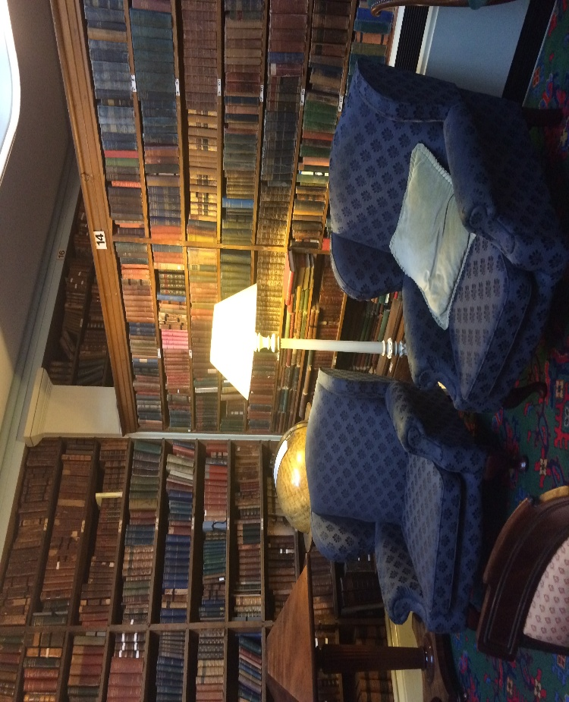
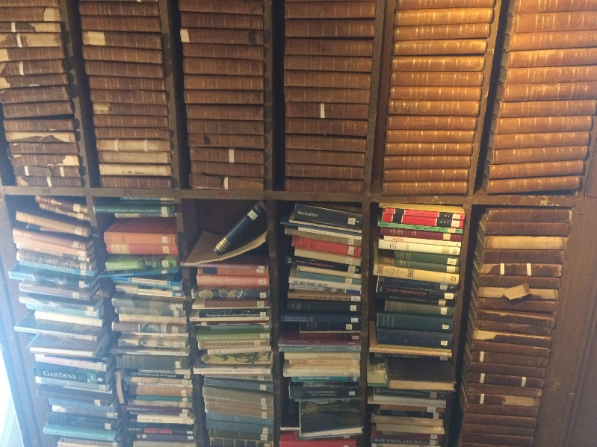

Cheryl Cooper.
Contents
Rolls Series 3
Local History – Local Class Mark S. 5
Other Local History in various sections 9
Royal History of England, Scotland and Ireland – Local Class Mark B 12
General History- Local Class mark C. 16
More recent secondary literature. 19
Sections not covered. 20

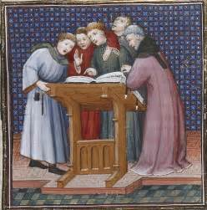

Rolls Series
Language: Latin.
C. 101 – C. 103 – General History - Bay 57 (bottom shelf).
C. 104 – C. 110 – General History - Bay 10.
- Domesday-Book – Seu Liber Censualis Willelmi Primi .(1783).
Series: Record Commissioners, 1783.
Shelf: C.101.1.4.
Oldest edition held by the DEI – Edited by Abraham Farley.
- Domesday-Book – Sue Liber Censualis, Willelmi Primi Regis Angliae. (1783 – 1816).
Series: Record Commissioners, 6-7.
Shelf: C.101.1.4.
Later edition edited by Henry Ellis.

- Calendarium Rotulorum Chartarum. (1803).
Series: Record Commisioner Publications; 53.
Shelf: C.101.12.
Charter Roles from 1199 – 1483.
- Taxatio Ecclesiastica Angliae at Williae auctoritate, P. Nicholai. (1802).
Series: Record Commissioners Publications; 50.
Shelf: C.101.13.
Ecclesiastical taxation of English and Welsh parish churches. (1291).

- Foedera Coventiones. (1816).
Series: Record Commissioners Publications; 11.
Shelf: C.101.5-11.
Four parts in seven volumes.
Thomas Rymer.
Volumes documenting the agreements made between the Crown of England and foreign powers during earlier centuries.

- Registrum Magni Sigilli Regum Scotorum. (1814).
Series: Record Commissioners.
Shelf: C.102.17.
Scottish charters (1306 – 1424).

- Rotulorum Orgininalium in curia scaccarii abbreviation. (1805 – 1810).
Series: Record Commissioners Publications; 1.
Shelf: C.102.5-6.
Exchequer Rolls – 13th c – x2 volumes.

- Testa de Nevill. (1807).
Record Commissioners Publications ; 54.
Shelf: C.102.7.
Exchequer records (1216 – 1307).

- Nonarum Inquisitiones in curia scaccarii. (1807).
Series: Record Commissioners Publications; 3.
Shelf: C.102.8.
Nonae Rolls / Taxation of Great Britain (1327 – 1377).

- Rotuli Hundredorum temp. (1812 – 18).
Series: Record Commissioners Publications; 55.
Shelf: C.103.4-5.
2 x volumes.
Government enquires of 1255. Royal rights, forest rights, landholdings.
(1274 – 1275) Liberties and misdeeds of officials.
(1279 – 1280) Landholding.
Extract rolls of original returns of 1274.

- Rotuli Scotiae in Turri Londinensi et in Domo Capitulari. (1814 – 1819).
Series: Record Commissioners Publications; 10.
Shelf: C. 103.7.8.
Scottish charters, grants, privileges, 13th c, x2 volumes.

- Placita de quo warranto. (1818).
Series: Record Commissioners Publications; 56.
Shelf: C. 103.9.
Pleas and land titles (13th – 14th c).
S. 17 – S. 40 – Topography - Bay 46.

- The Register of Walter de Stapledon, Bishop of Exeter. (1892).
Series: Episcopal Registers of The Diocese of Exeter 1307 – 1326.
Shelf: S. 28. 7.

- The Register of John de Grandisson Bishop of Exeter. (1894).
Series: Episcopal Registers of The Diocese of Exeter 1327 – 1369.
Shelf: S. 28. 10-12.
Some accounts of James de Berkley.

Local History – Local Class Mark S.

S. 1 – S.1 9 – Topography - Bay 45.
S. 9 – S. 12 – Topography - Bay 62.
S. 13 – S. 16 – Topography - Bay 63.
S. 17 – S. 40 – Topography - Bay 46.
S. 38 Oversize – Topography - Bay 9 (bottom shelf).
S. 41 – S. 61 – Topography - Bay 47.
S. 65 – S.70 – Topography - Bay 64.
Section S1 – S9 - largely secondary literature and a few primary sources concerned with the following topics:
Church history, ecclesiastical history, local traditions and antiquities within the church.
Episcopal registers of the diocese of Exeter.
The history of prominent families in the local area and genealogical history.
The history of armour, knighthood and heraldry.
The history of coins, gems and medals and the history of pastimes and sport.
Surveys of the local area.
Natural history.
Forest laws and charters.
Parish registers.
A few examples are listed below.

- The churches and antiquities of Cury and Gunwalloe in the Lizard District. (1875).
Author: Alfred Hayman
Shelf: S.1. 18.
History of St Corantyn’s Church and St Winwaloe Church. Also includes local traditions.

- The Ancient British, Roman and Saxon antiquities and folk-lore of Worcestershire (1852).
Author: Jabez Allies
Shelf: S. 1.19.

- The visitations of Cornwall, comprising the Herald’s Visitations of 1530, 1573 & 1620. (1887).
Author: J.L Vivian
Shelf: S.10. 14.

- Pedigree of the family Gibbs of Clyst St. George, Devon. (1904).
Author: Baron Henry Huck-Gibbs-Aldenham.
Shelf: S. 10. 20.

- A monograph of the House of Lempriere, its history from A.D 970 – 1863. (1862).
Author: J. Bertrand Payne
Shelf: S. 10.5
Lempriere House known as Rozel Manor has been in the Lempriere family since the 14th c who have been noted as one of the most important families in the history of Jersey.

- A History of the domestic manners and sentiments in England during the Middle Ages. (1862).
Author: Thomas Wright
Shelf: S. 2. 28.

- A statistical account of the parish of St Just in Penwith in the County of Cornwall. (1842).
Author: John Buller
Shelf: S. 25. 13.
Contains information on its ecclesiastical and druidical antiquities.

- Arms and Armour in antiquity and the Middle Ages. (1874).
Author: Charles Boutell
Shelf: S. 26. 10

- An index to printed pedigrees, contained in County and Local histories. (1867).
Author: Charles Bridger
Shelf: S. 26. 18.

- The Register of Edmund Lacy, Bishop of Exeter - 1420 – 1455. (1909).
Author: Charles Francis, Hingeston-Randolph.
Shelf: S. 28. 15.
Information regarding the register on institutions and some information on John Catrick.

- Heraldic church notes from Cornwall. (n.d)
Author: Arthur J. Jewers
Shelf: S. 29. 19
Contains the heraldry and genealogy in ten churches in Cornwall.

- Medii Aevi Kalendarium (Dates, Charters and Customs of the Middle Ages (1841).
Author: R.T Hampson.
Shelf: S. 3. 4-5.
Latin

- An Armory of the Western Counties (Devon and Cornwall). (1898).
Author: Robert Twigge
Shelf: S. 30. 21.
From unpublished manuscripts of the 16th c.

- A History of Bristol Cathedral: Its Antiquities and Monuments. (1854).
Author: Peter Leversage
Shelf: S. 4. 30.

- Survey of Cornwall. (1811).
Author: Richard Carew.
Shelf: S. 48. 6.
Notes and illustrative history of Cornwall.
There is also a modern addition of this published by the Devon and Cornwall Record Society.

- The History of Taunton Priory in the Country of Somerset. (1860).
Author: Hugo Thomas
Shelf: S. 49. 12.

- The Mediaeval Nunneries of the County of Somerset and Diocese of Bath and Wells. (1867).
Author: Charles Welch.
Shelf: S. 49. 17.

- The Parochial and Family History of the Deanery of Trigg Minor in the County of Cornwall. (1873).
Author: Sir John McClean.
Shelf: S. 49. 6-8.

- The Ancient Cathedral of Cornwall Historically Surveyed. (1804).
Author: John Stockdale.
Shelf: S. 49. 9 – 10.

- The History of Cornwall from the earliest records and traditions to the present time. (1784).
Author: Fortescue Hitchins.
Shelf: S. 50. 9 – 10.

- The Genealogy of the Courtenay Family. (1853).
Author: George Oliver.
Shelf: S. 53. 17.

- The History and description, ancient and modern of the City of Exeter. (1802).
Author: Thomas Brice.
Shelf: S. 53. 20.

- On Some Anglo-Saxon Charters at Exeter. (1883).
Author: James, B. Davidson.
Shelf: S. 53. 26.

- The Alchemical Testament of John Gybbys of Exeter. (1854).
Author: John Gybbys.
Shelf: S.53. 31. P
Probably edited from an Ashmole MS (now in the Bodleian Library) dated 1423.
- A Topographical, Ecclesiastical and Natural History of Devon. (1655).
Author: Thomas Cox.
Shelf: S. 53. 4.
Pedigrees of noble families and gentry. Biographical accounts of learned men. Alphabetical table of towns, villages and hamlets.

- Annals of the Ancient Royal Forest of Exmoor. (1893).
Author: John, Edwin. Rawcliffe.
Shelf: S. 54. 15.
Accounts of ancient forest law and charters.

- Barnstaple Parish Register of baptisms, marriages and burials, 1538 – 1812. (1903).
Author: Thomas Wainwright.
Shelf: S. 54. 15.

- The Account of the Wardens of the Parish of Morebath, Devon, 1520 – 1573. (1904).
Author: J, Erskine. Binney.
Shelf: S. 54. 19.

- A literal translation of the part of Domesday Book relating to the County of Cornwall. (1875).
Author: Sir Henry James.
Shelf: S. 56. 23.

- Domesday Book, The Great Survey of England of William the Conqueror – part relating to Cornwall. (1861).
Southampton Ordnance Survey Office.
Shelf: S. 56. 21.

- Domesday Book, The Great Survey of England of William the Conqueror – part relating to Devonshire. (1862).
Southampton Ordnance Survey Office.
Shelf: S. 56. 25.

- Monasticon dioecesis Exoniensis (1846).
Author: George Oliver.
Shelf: S. 54. 4.
Collections of records illustrating the foundations of ancient monasteries, colleges and charities in Devon. Also includes historical notices and a list of dedications of churches. Also an abstract of chantry rolls.

- The History and Antiquities of the Cathedral Church of Exeter. (1826).
Author: John Britton.
Shelf: S. 53. 30.

- Dunster and its Lords, 1066 – 1881. (1882).
Author: Sir Henry. Churchill-Maxwell-Lyte.
Shelf: S. 9. 11.

- Domesday Studies: an analysis and digest of the Somerset Survey (1880).
Author: Rev. R.W., Eyre.
Shelf: S.9. 8-9.
Drawing on the Exon Codex and the Somerset Gheld Inquest of 1084.

Other Local History in various sections
- Somerset Medieval Wills. (1901).
Editor: F.W Weaver
Shelf: S.W Periodicals
Wills from1383 – 1558.
- Education and Learning at a medieval English Cathedral – Exeter, 1380 – 1548.
Author: Nicholas Orme.
Shelf: AD/EXE 726. 65.

- Medieval Gaol delivery rolls for the County of Devon (1986).
Editor: A.J Howard.
Shelf: AD 08 HOW X

- The use of Exeter Cathedral according to John de Grandisson. (1891).
Author: Herbert,. Edward. Reynolds.
Shelf: SW. Cupboard
John de Grandisson, Bishop of Exeter, 1327 – 1367. Abstract of Chapter Acts and other documents illustrating the history of the Church and Diocese of Exeter – Devon and Cornwall, 1380 – 1660.

- The Consecration of the Norman Minister at Exeter 1133. (N.D).
Author: Percy Morris.
Shelf: AD/EXE 726. 62.

- A Collection of medical books and manuscripts including a selection of the scientific works in Exeter Cathedral Library.
Compiled by M.P Crighton.
Shelf: AD/EXE 726. 65.

- Translations from the Exeter Book: Selections of Anglo-Saxon poetry from manuscripts in the library at Exeter Cathedral. (1970).
Editor: Arthur Goodwin.
Shelf: 829. 101.

- A Concordance of medieval catalogues and surviving manuscripts in Exeter Cathedral Library. (1987).
Author: Ian Maxted.
Shelf: AD/EXE 726. 65.

- A Fragment of an Anglo-Saxon Benedictional preserved at Exeter Cathedral. (1904).
Author: F.H., Stanford.
Shelf: AD/EXE 726. 65.
Items in this section that are also of interest to medievalists and not specifically related to the local area, a few examples as follows:
- The Ancient and present state of the University of Oxford (1714).
Author: John Ayliffe.
Shelf: S.1. 11.

- The early genealogical history of the house of Arundel. (1882).
Author: John Pym. Yeatman.
Shelf: S. 10. 1
Concerns the families of Montgomery, Albini, Fitzalan and Howard.
- The Celt, The Roman and The Saxon: A History of the early inhabitants of Britain (1861).
Author: Thomas Wright
Shelf: S. 2. 29
Covers the conversion of the Anglo-Saxon’s to Christianity.

- Memorabilla Cantabridge: An account of the different colleges in Cambridge (1803).
Author: Joseph Wilson.
Shelf: S. 25. 11.
Latin – contains sketches of the founders and eminent men, anecdotes and views of the colleges and founders.

- London Marriage Licenses, 1521 – 1869. (1887).
Shelf: S. 28. 1
- The Boke of Saint Albans (1881).
Author: Dame Juliana Berners
Shelf: S. 30. 10
Taken from a source originally printed in 1486 by the St Alban’s schoolmaster. Contains a treatise on hawking and armour.

- Wardrobe Account of Edward I. (1787).
Shelf: S. 30. 7.
- A collection of ordinances and regulations for the government of the Royal Household – King Edward III. (1790).
Shelf: S. 30. 7.
Also contains ancient cookery receipts.

- The White Book of the City of London – complied in 1419 by John Carpenter. (1861).
Shelf: S. 4. 28.
Translated from original Latin and Anglo-Norman by Henry Thomas-Riley.

- A History of St Augustine’s Monastery, Canterbury (1901).
Author: Robert James Edmund Boggis.
Shelf: S. 4. 30.

- A Survey of the Cathedral Church of Worcester, with an accounts of the Bishops. (1737).
Shelf: S. 48. 23.
History from the foundation to 1600 – the appendix also contains many original papers.

- History of the Tower Bridge and other bridges over the Thames. (1894).
Author: Charles Welch.
Shelf: S. 49. 18.
Includes a 12th c account of the Bridge House Trust.

- Historical memorials of Canterbury: The Landing of Augustine, the murder of Becket, Edward the Black Prince and Becket’s Shrine. (1857).
Author: Arthur Penrhyn - Stanley.
Shelf: S. 6. 6.

14. The History and Antiquities of the Cathedral Church of Canterbury. (1727).
Author: John Dart.
Shelf: S. 61. 3.
History of the cathedral and monastery, containing the lives of archbishops, priors, An appendix of ancient charters and writings.

Royal History of England, Scotland and Ireland – Local Class Mark B
B. 1 – B. 27 – British History - Bay 7
B. 28 – B. 30 – British History - Bay 8 (bottom shelf).
B. 31 – B. 32 – British History - Bay 6 (top shelf).
Section B1 – B6 - largely secondary literature and a few primary sources concerned with the following topics; Kings and Queens of England and Scotland, parliamentary history, history of England, Scotland and Ireland, The Domesday Book, The Plantagenets, The Tudors, Henry II, Henry III, France,
Some examples below:
- Rerum Scoticarum History (1762).
Author: George Buchanan
Shelf: B. 3-4.
In English – the history of Scotland from the earliest accounts to the reign of James VI. 2x Volumes.
- Historia Regum Britannie (1718).
Author: Geoffrey of Monmouth
Shelf: B. 11. 7.
English - translated from original Latin.

- Peter Langtoft’s Chronicle – improved by Robert of Brunne (1725).
Author: Pierre de Langtoft (1307).
Shelf: B. 15. 22
First publication from a MS – added addition of a glossary.
Includes ‘curious papers’, a roll concerning Glastonbury Abbey, an account of St Mary Magdalen’s and Stonehenge.
Other medieval authors include – Robert Mannyng (1288 – 1388).
- Robert of Gloucester’s Chronicle (1724).
Author: Robert of Gloucester (1260 – 1300).
Shelf: B. 15. 23.
First publication from a MS.
Language: Middle English.
- Historiae Anglicanae Scriptores. (1652).
Editor: Sir Roger Twysden.
Shelf: B. 29. 8- 9.
Latin
Church history from 1066 – 1485.
Various authors of note for the medieval period– Gervase of Canterbury, Simeon of Durham, John of Hexman.
- Domesday Book – Wiltshire (1788).
English and Latin.
Shelf: B.18 17.
Wiltshire - extracted from Domesday book. Translation of original Latin with a plan for the general history of the country by Henry Penruddocke.
- Court Life Under the Plantagenets: Reign of Henry II. (1890).
Author: Hubert Hall.
Shelf: B. 18. 23.
Includes five coloured plates by Richard Neville.
- A perfect copy of all summons of the nobility to the great councils and parliaments of this realm. Henry III to present times. (1685).
Author: Sir William Dugdale.
Shelf: B. 19. 10.
Latin with English preface.
Taken from public records.
- The New Chronicles of England and France. (1811).
Author: Robert Fabyan (1513).
Shelf: B. 19. 12.
Reprinted from Pynson’s editon of 1516. Added index by Henry Ellis.
- Original Letters written during the reigns of Henry VI, Edward IV and Richard III. (1787).
Author: Paston Family
Shelf: B. 19. 13 – 17.
Written by various persons of rank. Containing curious anecdotes. Insight to private manners of the age as well public matters of state.
- Chronicle at Large or Grafton’s Chronicles or History of England. (1809).
Author: Richard Grafton.
Shelf: B. 20. 4-5.
Table of bailiffs, sheriffs and mayors of London from 1189 – 1558.
Reprint by Henry Ellis.
- Halls Chronicle. (1809).
Author: Edward Hall (1547).
Shelf: B. 20. 6.
History of England during the reign of Henry VI and succeeding monarchs.
- Anglo-Saxon Chronicle. (1823).
Shelf: B. 23. 16.
Written in English and Old English.
Anglo-Saxon and English written in parallel columns. English translation and notes. Also added are chronological, topographical and glossarial indices and a short grammar of the Anglo-Saxon language.
- The History and Antiquities of Scotland. (1693).
Author: William Maitland.
Shelf: B. 23. 5 – 6.
From the earliest account of time to the death of James I.
- Historie and the lives of twentie kings of England. (1628).
Author: William Martyn.
Shelf: B. 23. 9.
From William the Conqueror until Henry VIII. The successions of the dukes and earls of the kingdom of England.
- Anglo-Saxon Bishops, Kings and Nobles: The Succession of The Bishops and Pedigree of the Kings and Nobles. (1899).
Author: George Searle.
Shelf: B. 24. 6.
- Select pleas in manorial and other seigniorial courts – Reigns of Henry III and Edward I. (1899).
Series: The Publication of the Selden Society; 2.
Shelf: B. 24. 6.
Edited by F.W Maitland.
Parallel texts in English and Latin.
- Select pleas, stars and other records from the Rolls of the Exchequer of the Jews: 1220 – 1284. (1902).
Series: The Publication of the Selden Society; 15.
Shelf: B. 24. 8.
Parallel text in Latin and English.
- The Chronicle of England. (1777).
Author: Joseph Strutt.
Shelf: B. 25. 1.
Anglo-Saxon period 144 – 1066 – Volumes 1 & 2.
- Visits to Rochester and Chatham made by royal, noble and distinguished personages, 1300 – 1783. (1865).
Author: William Brenchley-Rye.
Shelf: B. 27. 3.
Reprinted from ‘Archaeologia Cantiana, Vol V.I.
- Foedera, conventiones, litrae et cujuscunque generis acta publica inter reges Angliae.
(17th c),
Author: Thomas Rymer.
Shelf: B. 27. 6 – 15.
Latin. Letters from the Kings of England from the 12th c.
- Baronia Anglica: A History of the land-honours and baronies, and of tenure. (1741).
Author: Thomas Madox.
Shelf: B. 28. 12.
Mostly in English but large sections have been taken from records in Latin.
- The Historie of Great Britaine under the conquests of the Romans, Saxons, Danes and Normans. (1632).
Author: John Speed.
Shelf: B. 29. 10.
Covers the manners, habits, warres, coins and seals. Descendants of Anglo-Saxon Kings, their marriages and armies. Includes a leaf of plates, illustrations and woodcuts. Also a catalogue of religious houses with their orders, founders, benefactors and values.
- Historie Anglicanae Scriptores. (1652).
Author: Sir Roger Twysden.
Shelf: B. 29. 8 – 9.
Medieval Authors: Simeon of Durham (1130), John of Hexham (1180), Richard of Hexham (1138 – 1154), Thomas Stubbs (1373), Gervase of Canterbury (1188), William Thorne (1397).
- Select charters and other illustrations of English Constitutional history from earliest times to Edward I. (1876).
Author: Bishop William Stubbs.
Shelf: B. 32. 12.
- A general introduction to the Domesday Book. (1833).
Author: Henry Ellis.
Shelf: B. 6. 1.
An index of the tenants in chief and under tenants at the time of the survey. Holders of the land, abstract of the population.

General History- Local Class mark C.
C. 1 – C. 24 – Bay 8.
C. 25 – C. 42 – Bay 9.
C. 43 – C. 54 – Bay 11.
C. 57 – C. 58 – Local History.
Section C1 – C58 - largely general history, some local history and biographical reference works. Chronicles of England, Anglo-Saxon Chronicles, History of medieval France, Italian History, Irish History.
Some examples below:
- An Epitome of universal history: ancient and modern from the earliest authentic records to the commencement of the present year. (1813).
Author: Francis Baily.
Shelf: C. 1. 19 – 20.
- Six Old English Chronicles. (1891).
Author: J.A Giles
Series: Bohn’s Antiquarian Library.
Shelf: C. 109. 20.
Translated from Monkish Latin originals.
Includes Ethelwerd’s chronicles - Asser’s Life of Alfred – Geoffrey of Monmouth’s British History – Gildas – Nennius – Richard of Cirencester.
- Gesta Regum Anglorum.(1847).
Author: William of Malmesbury (1090 – 1143).
Shelf: C. 109. 21.
William of Malmesbury’s Chronicle of the Kings of England: From the earliest period to the reign of King Stephen. Based on the translation from the Latin by John Sharpe.
- A Literary History of the Middle Ages. (1814).
Author: Joseph Berington.
Shelf: C. 19. 12.
From the close of Augustus to the 15th C.
- Blair’s Chronolgical and historical tables, from creation to the present time. (1851).
Author: John Blair. (1782).
Shelf: C. 19. 16.
Includes additions and corrections from the most authentic writers. The present volume has been reconstructed from a folio edition by John Sharpe and the revision of the manuscript by Henry Ellis.
- Palaelogia Chronica: A Chronological Account of Ancient Time. (1677).
Author: Robert Cary.
Shelf: C. 20. 16.
- Istoria Civile del regno di Napoli. (1753).
Author: Pietro Giannone.
Shelf: C. 24. 3 – 6.
- Chronicles Of the Crusades. (1848).
Author: Henry Bohn.
Shelf: C. 26. 24.
Contemporary narratives of the Crusade of Richard Coeur de Lion by Richard Devizes and Geoffrey de Vinsauf - translated from Latin. Crusade of Saint Louis - translated from Old French.
Geoffrey de Vinsauf largely a Latin translation of Ambroise’s L’estorie de la guerre sainte.
- The History of the Crusades for the recovery and the possession of the Holy Land. (1820).
Author: Charles Mills.
Shelf: C. 27. 2 – 3.
- The Chronicles of Enguerrand de Monstrelet. (1810).
Author: Monstrelet.
Shelf: C. 27. 20 – 32.
Approx 1390 – 1453.
Contains an account to the civil war between the houses or Orleans and Burgundy. The possession of Paris and Normandy by the English.
- The History of Chivalry or Knighthood and its times. (1825).
Author: Charles Mills.
Shelf: C. 27. 4-5.
- The History of the Battle of Agincourt. (1827).
Author: Sir Nicholas Harris.
Shelf: C. 29. 23.
Expedition of Henry VI into France. Roll of men at arms in the English army.
- View of the state of Europe during the Middle Ages. (1818).
Author: Henry Hallam.
Shelf: C. 37. 1. 2.
- A General History of Ireland from the earliest accounts to the close of the 12th c. (1778).
Author: Sylvester O’Halloran.
Shelf: C. 37. 17 – 18.
- The History of the Anglo-Saxons. (1807). ~
Author: Sharon Turner.
Shelf: C. 38. 20.
- Rotuli Litterarum Clausarum in Turri Londinensi asservati. (1844).
Series: Record Commissioner Publications, 15.
Shelf: C. 42.
A letter stored in the Tower of London, 1224 – 1227.
- Facsimiles of national mauscripts from William the Conqueror to Queen Anne. (1865).
Shelf: C. 42. 16.
- A System of Chronology. (1784).
Author: James Playfair.
Shelf: C. 42. 2.
Contains a list of eclipses before the Christian era and all eclipses from A.D. 1 – A.D. 1900.
- Calendarium Rotulorum Patentium in Turri Londinsensi. (1802).
Series: Public Record Office.
Shelf: C. 42. 3.
Debt Rolls – 1154 – 1399.

More recent secondary literature.
Section H0 - British History
Bay 38 & 40.
Covers more modern secondary works in which historians are focusing on the medieval period.
Some examples:
- English Rural Society, 1200 – 1350. (1969).
Author: J. W. Titow.
Shelf: H03 (330). TIT.
- Bosworth Field: From Medieval to Tudor England. (1966).
Author: Alfred,. Leslie. Rowse.
Shelf: H043. R0W.
- The Early Charters of Eastern England. (1966).
Author: R. C. Hart.
Shelf: H01. (333).
- The Medieval Borough: Studies on its origins and constitutional history. (1936).
Author: James Tait.
Shelf: H02. (352). TAI.
- Domesday Book through nine centuries. (1986).
Author: Elizabeth., M. Hallam.
Shelf: H02. HALL.
- The English Secular Cathedrals in the Middle Ages: A Constitutional Study With Special Reference To The Fourteenth Century. (1949).
Author: Kathleen Edwards.
Shelf: H03. (274). EDW.

Sections not covered.
The Devon and Exeter Institute boasts a large collection of books and unfortunately there was not time to cover the entire collection. However, below is a list of the library categories not covered which may be of interest to some medievalists to explore in more detail.
Section A – Theology
Section D – English Lit
Section E – Reference
Section F – Fiction
Section G – Travel
Section – I – Philosophy, Law and Statutes
Section J – Science
Section K – Classics – I did look at this section and there was no medieval material here.
Section L- Arts
Section N – Natural History – Again I briefly looked through this section and could not identify any medieval material. However, this perhaps needs looking at in more depth by someone who has a greater knowledge of Natural History.
Section O – Biography.

